Project Phase 0: Proposal

### IDEA

We have come up with an idea to develop a mobile application which serves an objective to deliver food around the city, around the country and hopefully around the globe. We have decided to name this application **MILESTONE MEALS.**

**FEATURES**

Just like every other mobile application this application will be equipped with important and useful features. As this application deals with the food delivery so the features which will enhance its quality can be used. Below are few features which can be included:

* This application will be having SignUp/SignIn, Add to cart, Order, View Order like features.
* This application would be Multipage and networked as there will be more than three pages which will be connected or we can say dependent upon each other.
* We are also planning to make it more interactive by using simple English language and interesting images or photos.

**EXPECTED LAYOUT OF PAGES**

*(REFERNCE: SKIP THE DISHES)*

** 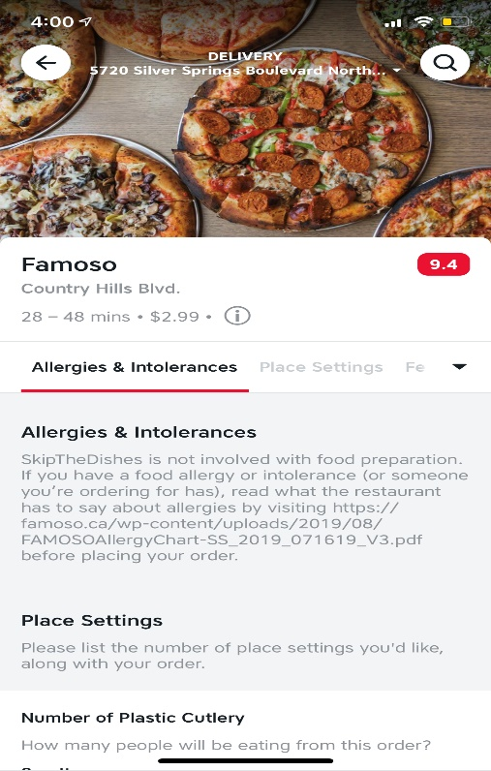

(*This would be our Home Page Consisting of Different*

*Restaurants and Food types.)*

   



**APPLICATION LIFECYCLE**

*(LOOK OUT THE ABOVE IMAGES)*

* **First Page would be the home page including different restaurants and food items.**
* **On tapping on any of the restaurants second page will open and that page would be showing all the dishes it delivers.**
* **On tapping on any of the dish, third page will open giving the details about the dish and there would be an option of Add to order.**
* **On tapping on Add to order a new page will open consisting of view order.**
* **After clicking on view order, a new Check out page will open to finally order the item.**
* **However, to order or check out a dish a person need to sign up, so a sign up page will pop up.**
* **So after signing up and signing in, Payment gateway should open but right now we will focus more on designing and creating functionalities.**
* **We will try to add a payment gateway but it would be very difficult.**

**Conclusion**

**We would like to conclude our proposal here and we will not left any stone touched to make this app a successful one.**

**Thanks and Regards**

**Team ALPHA**